**Report on Automated streetlight management system using IOT**

Serial number -9

Registration Number – RA1711008010291

Name – Aniket khare

Batch number -2

Faculty Name: Dr.Kayalvizhi Jayavel/IT

1. Abstract-

The aim of automated streetlight management system using IOT is the conservation of energy by reducing electricity wastage as well as to reduce the manpower. Streetlights are the elemental part of any city since it facilitates better night visions, secure roads, and exposure to public areas but it consumes a quite large proportion of electricity. In the manual streetlight system lights it’s powered from sunset to sunrise with maximum intensity even when there is sufficient light available. This energy wastage can be avoided by switching off lights automatically. The saved energy can be efficiently utilized for other purposes like residential, commercial, transportation etc. This can be achieved using an IOT enabled streetlight management system. The project uses Light Emitting Diodes (LED) that does not consume an enormous amount of electricity to replace the power consuming traditional HID lamps. LED lights along with LDR enable the intensity variation which is infeasible with the HID lamps. As LEDs are directional light sources it can emit light in specific direction thereby optimizing the efficiency of the street lights. This system includes an additional DHT11 Temperature-Humidity sensor. This provides the exact temperature and humidity of a particular region. DHT11 is a composite sensor that contains a calibrated digital signal output of the temperature and humidity. It ensures high reliability and excellent long-term stability. This work is implemented using a programmed Arduino board for providing the required intensity of light at various times. The proposed work has achieved a better performance compared to the existing system. In conclusion I would like to say that the main aim is to cut down the energy wastage that our country is finding difficult to tackle by developing this automated street light this can be achieved.

2. INTRODUCTION-

Nowadays, a human has become too busy and is unable to find time to switch the lights wherever not necessary. The present system is like the lights will be switched on in the evening before the sun sets and they are switched off the next day morning after there is sufficient light on the outside. But the actual timing for these lights to be switched on is when there is absolute darkness. With this, the power will be wasted up to some extent.

Streetlights are an integral part of any developing locality. They are present on all major roadways and in the suburbs too. Every day, streetlights are powered from sunset to sunrise at full strength, even when there is no one around. On a global scale, millions of dollars are spent each day on these street lights to provide the required electrical energy. The maintenance and replacement costs of conventional incandescent bulbs are immense. They consume a lot of electric power to function and their heat emissions are also quite high. All of this contributes to the greater demand for electricity production and consequently, more carbon dioxide emissions from powerhouses. So, along with unnecessary light pollution, this practice causes damage to our planet too.

3. Requirements -

* Arduino
* Raspberry pi
* LDRs
* Relays
* WiFi Module
* Current Sensor
* IR Sensor
* Intel Galileo Gen2

4. Circuit diagram using Fritzing

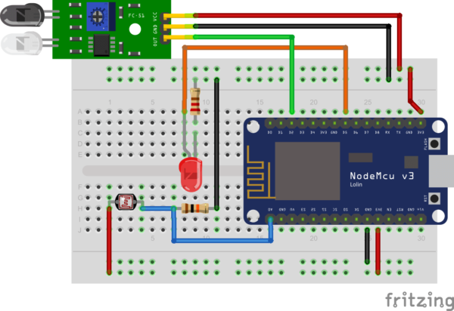

5. Methodology –

Functional Description The present system employs power delivery via a single-phase line to the streetlight. The proposed system involves five more components to regulate the power delivery. An Infrared Proximity Sensor at the base of the street light detects the presence in a small area around the street light. The data from the sensor is sent to the Arduino which forms brain of the circuit. The Arduino then commands to switch between dim and bright modes depending upon the Requirement and thus controls the brightness of the street light. A battery eliminator, also Powered by the single-phase line, is used to supply 5V inputs to the sensors and Arduino.

The design basically includes three working modes: - 1. OFF mode: When there is enough natural light in the surrounding i.e. during the daytime, the entire system is switched off and the batteries are charging. 2. Active mode: When the natural light drops below a certain level the system automatically turns on and the motion sensors are powered. 3. ON mode: On the presence of pedestrians, the sensors turn on which in turn switches on the LED lights. These lights turn off after a period.

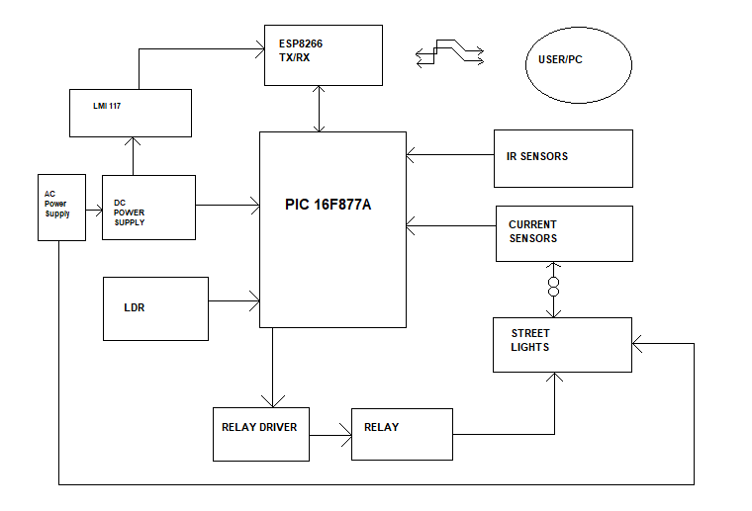

The system architecture of the intelligent street light system consists of IR sensors, LDR,PIC16F877A microcontroller, Relay, UART and Wifi Module. LDR‟s are light dependent devices whose resistance decreases when light falls on them and increases in the dark. When a light dependent resistor is kept in dark, its resistance is very high. The vehicle which passes by the street light is detected by IR sensor. Relay are used as a switch to switch on/off the street light bulb. A UART (Universal Asynchronous Receiver/Transmitter) is the microchip with programming that controls a computer's interface to its attached street light system.

Coding Used –

int smooth;

int LDR;

int threshold = 40;//sun's intensity

int brightness = 0;

int ledState = 0;

int sensor1 = 11;

int sensor2 = 8;

int sensor3 = 9;

int led1=5;

int led = 6;

int led2=2;

int carPresent = 0;

int carPresent1 = 0;

float beta = 0.65;

void setup() {

// put your setup code here, to run once:

Serial.begin(115200);

pinMode(sensor1, INPUT);

pinMode(sensor2, INPUT);

pinMode(sensor3, INPUT);

pinMode(led,OUTPUT);

pinMode(led1,OUTPUT);

pinMode(led2,OUTPUT);

}

void loop() {

smooth = smooth - (beta * (smooth - analogRead(A0)));

delay(1);

LDR = round(((float)smooth / 1023) * 100);

if (LDR <= 40)

brightness=0;

else

{

brightness = map(LDR, 40, 100, 0, 255);

}

checkSensors();

if (carPresent == 1)

{

ledState = 1;

digitalWrite(led,HIGH);

digitalWrite(led1,HIGH);

analogWrite(led,brightness);

analogWrite(led1,brightness);

}

else if (carPresent == 0)

{

ledState = 0;

digitalWrite(led,HIGH);

//digitalWrite(led1,HIGH);

analogWrite(led,ledState);

//analogWrite(led1,ledState);

if(carPresent1 == 1)

{

ledState = 1;

if(ledState == 1)

{

analogWrite(led1,brightness);

analogWrite(led2,brightness);

}

}

else if (carPresent1 == 0)

{

ledState = 0;

digitalWrite(led1,HIGH);

digitalWrite(led2,HIGH);

analogWrite(led1,ledState);

analogWrite(led2,ledState);

}

}

String data = (String)ledState+","+(String)brightness+";";

Serial.print(data);

// Serial.print(digitalRead(sensor1));

// Serial.print("\t");

// Serial.print(digitalRead(sensor2));

// Serial.print("\t");

// Serial.print(ledState);

// Serial.print("\t");

// Serial.println(brightness);

delay(100);

}

void checkSensors()

{

if (digitalRead(sensor1) == 0)//Car captured in 1st sensor

{

if (digitalRead(sensor2) == 1)//Car still didnt reach the 2nd sensor

carPresent = 1;

}

else if (digitalRead(sensor2) == 0)//Car reached the 2nd sensor

{ //No cars detected behind the first car

if (digitalRead(sensor1) == 1)

{

carPresent = 0;

carPresent1 = 1;

}

else if (digitalRead(sensor1) == 0 )

{

analogWrite(led,brightness);

analogWrite(led1,brightness);

analogWrite(led2,brightness);

digitalWrite(led,HIGH);

digitalWrite(led1,HIGH);

digitalWrite(led2,HIGH);

}

}

else if(digitalRead(sensor3) == 0)//car reached the 3rd sensor

{

//No cars detected behind the first car

if (digitalRead(sensor2) == 1)

{

carPresent = 0;

carPresent1 = 0;

}

else if (digitalRead(sensor2) == 0 )

{

carPresent = 0;

carPresent1 = 1;

}

}

}

APPLICATIONS

We can use it outside the house, corridors or industry area, which helps to save power.

In sea off-shore side we can use it as a dangerous sign.

Street lights use photoresistors to detect whether it is day or night and turn the light on or off accordingly.

It can be used in some clocks, alarms, and other electronic devices that are dependent on sunlight.

CONCLUSION

The use of power electronics is increasing exponentially across various sectors of human life. The components used in the project, like Arduino and sensors are slowly becoming an indispensable part of our daily routines. So, it is only fitting that we use them to improve efficiency in every walk of life. Keeping in mind the urgent need for energy conservation, Solar Smart Street Light System with IoT is an excellent and effective solution. It combines safe lighting protocols with consumption of a minimal amount of power. The energy savings are phenomenal. The future scope of this project expands into speed detection and customizable area of illumination. An additional component which would lead to better functioning of the concept would be the use of LED bulbs. Despite their high initial costs, they are a viable option as they drastically reduce the power consumption. They will aid in further saving of energy and reduction in operational cost.

Git hub link -https://github.com/coderakstar/IOT-Project.git

REFERENCES

[1] 2017 IEEE Region 10 humanitarian Technology conference (R10-HTC)

[2] <https://en.wikipedia.org/wiki/ESP8266>

[3] Thing Speak.com

[4] <https://store.arduino.cc/usa/arduino-uno-rev3>

[5] http://www.fecegypt.com/uploads/dataSheet/1480848003_2_channel_5v_10a_relay_module.pdf [6] Cho, S. K., and Dhingra, V. (2008). “Street Lighting Control Based on Lon Works Power Line Communication,” IEEE International Symposium on Power Line Communications and Its Applications, Jeju City, 2-4 April 2008, pp. 396- 398.

[7] International Telecommunication Union. (2005). Internet reports 2005: The internet of things. Geneva: ITU.

[8] Hachem, S., Teixeira, T., & Issarny, V. (2011). Ontologies for the internet of things (pp. 1–6). New York: ACM.

[9] Wan, J., Yan, H., Suo, H., & Li, F. (2011). “Advances in cyber-physical systems research”, KSII Transactions on Internet and Information Systems, 5(11), 1891–1908.

[10] Tsai, C., Lai, C., & Vasilakos, V. (2014). “Future internet of things: Open issues and challenges”. ACM/Springer Wireless Network.